MCj03710640000[1] MCj03710640000[1] MCj03710640000[1] MCj03710640000[1]

October 10 – October 14

First Grade Parents,

It is good to be back at school! Don’t get me wrong, I had wonderful time back in Indiana with my family!! I was “out in the sticks” though, and had no internet or WiFi at all…hence just getting this newsletter out to you today, So sorry about that! My hometown is surrounded by Amish country; here is a picture of typical traffic in that area…haha…(see the horse and buggy ahead of me at the stop sign??)

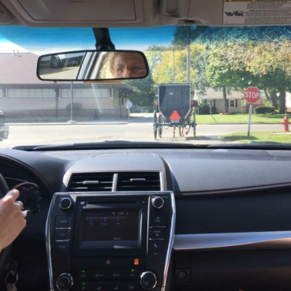

I hope that you are getting some work done on the saint projects. Just to be safe, rough drafts should be almost finished. What I did with my own children was read about the saint they had chosen together. I let my child choose the facts he or she thought was most interesting and we wrote the report with those facts. Remember Final Reports are due October 21st. They will be shared in class. It should be evident the report has been practiced at home. Children will not wear costumes that day, only on November 1st. The 2-3 facts that your child will be sharing at the Living Saint Museum need to be memorized by the 27th.

Our field trip to All Saints Church is Tuesday, October 25th. We will leave CTK by 8:10 so that we can attend Mass at 8:30 AM. After Mass, we will have a tour of the church. I am guessing that we will be back at the school around 11:30 AM. Permission slips are being sent home today. There is no cost for the field trip, but if your child would like to make a small financial offering to All Saints, I think that would be appropriate. I can collect that money and give it to our tour guide, If I do not have your child’s Transportation Form, I have also attached one of those. ALL children must be in car seats when driving to and from a field trip.

Today is the last day to order books from this month’s Scholastic book order. Mrs. Dennett will also be holding a book fair later this month.

Our parish Fall Fiesta is October 22nd. It is always a FUN event!! Pre-ordering tickets really helps out. Also, it is a great time to get some volunteer hours in. Look for links and detailed information in the Friday Flash.

Thank you to the Fitterer Family for providing snacks last week. This Next week is a short week so we will use some of the leftover snacks we have accumulated. The Maldonado Family will be providing ½ of the snacks when we return from Fall Break week. There is still a slot available for the other half.

  There is no school this Friday, or next Monday and Tuesday…enjoy your Fall Break!

May God Bless You,

Mrs. Stevason